**TRAFFIC RACER GAME**



Session: 2021 – 2024

**Submitted by:**

Muhammad Ibrahim       2021-CS-169

**Supervised by:**

Mis Maida Shahid

Department of Computer Science

**University of Engineering and Technology**

**Lahore Pakistan**

# CONTENTS

Game Description: 3

Game Characters Description 3

Rules & Interactions 4

Goal of the Game5

# GAME DESCRIPTION

Traffic Racer is a console-based game. It is a milestone in the genre of endless arcade racing. Drive your car through highway traffic, earn score points. There is total four paths for movement of traffic cars and player car Endless racing are now redefined!

**Key Features:**

* Endless drive
* Easy to control
* Smooth Game
* Leader Board to keep track of scores

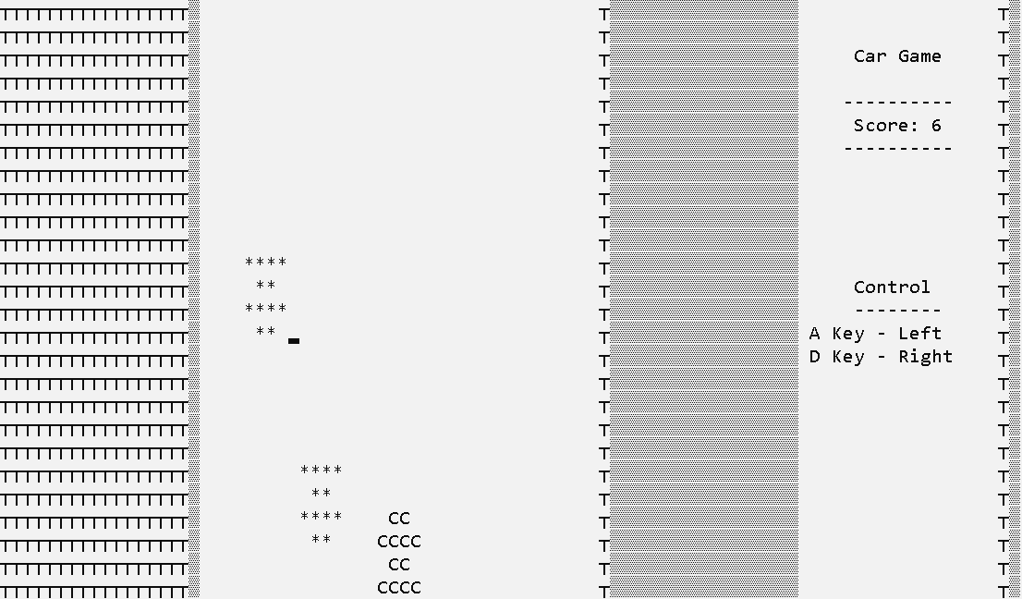

# GAME CHARACTER DESCRIPTION

Traffic Racer game has mainly three characters. The description of characters is as follows:

* 1 player car
* 2 traffic cars

**Player Car**:

It is made using character “C”. This car is controlled by player with the help of specific keys for certain operations. It looks like



**Traffic Car**:

It is made using character “*”. This car is controlled by computer. It looks like



# RULES & INTERACTIONS

**P**layer car can move left and right to switch between paths by using:

* “A” for left movement
* “D” for right movement

Traffic cars will move for up to down. Its movement and position depend on computer

# GOAL

The goal of the game is to earn highest score points to improve leader board while avoiding

the Traffic Cars.